Alexander Baldree
06/30/26
Module 5.2 & 6.2 CRUD-READ
CSD430

GitHub Link:
https://github.com/Panda-Alex21687/CSD430

File in Folders:
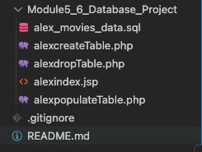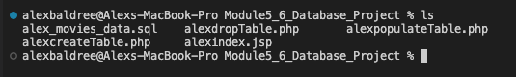

SQL File Run:
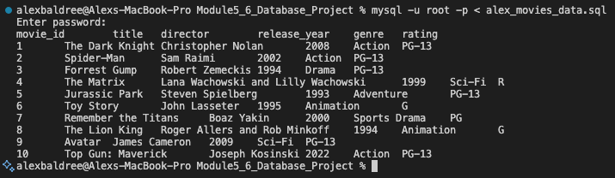

Student1 Login:
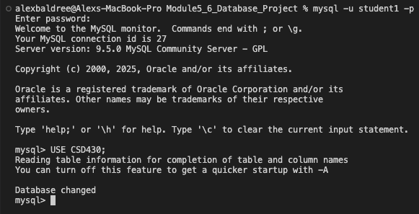

SHOW TABLE;
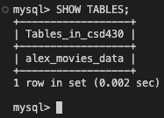

Describe Table:
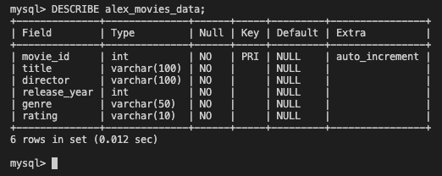

SHOW my 10 Records:
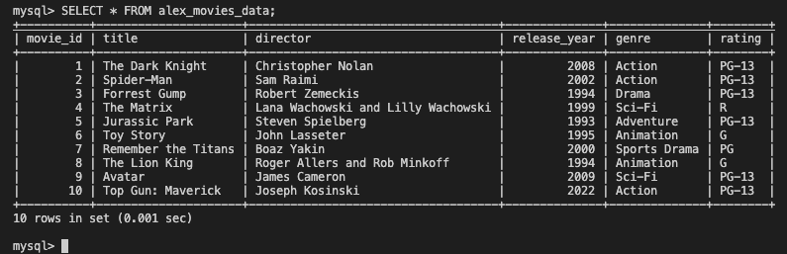

PHP Create Table:
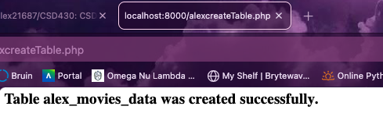
PHP Populate Table:
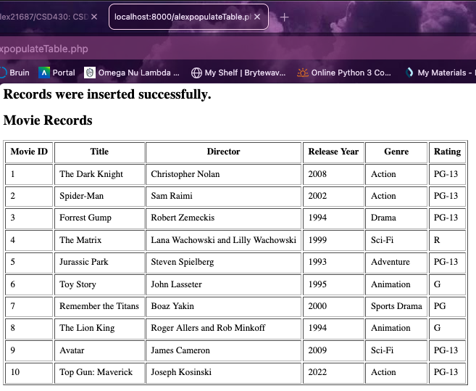
Index.sjp through Tomcat:
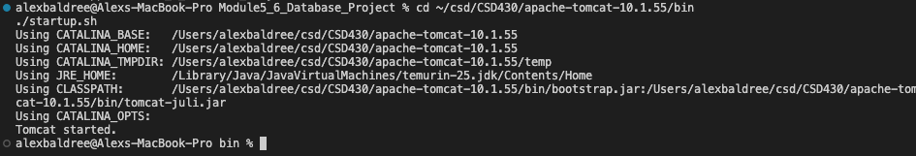
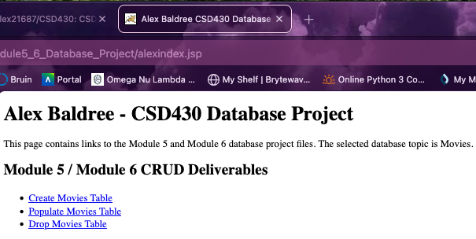

Drop Table:
